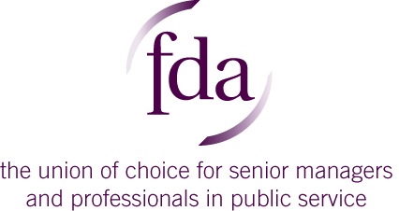

**Impact Award Nomination Form**

**2021**

The FDA launched our **Impact Award** in 2018 to recognise the hard work undertaken by members, reps and branches. Our Workplace Representatives and branches are the backbone of the FDA – from representing members in personal cases to recruiting new members to influencing employers on members’ behalf the work they do every day makes a real difference to FDA members’ working lives.

**To nominate an outstanding member, workplace rep or branch please complete this form and return by email to** [**amy@fda.org.uk**](mailto:amy@fda.org.uk) **by midday Monday 12th April.**

**Your name**

|  |
| --- |
|  |

**Name of the member, workplace representative or branch you are nominating**

|  |
| --- |
|  |

**In what area has the member, workplace representative or branch made a difference? (Please tick all that apply)**

|  |  |
| --- | --- |
| Campaign: where a campaign has been run in a local area resulting in engaging members and/or a win on an issue. |  |
| Engagement: members have been engaged to become more involved in FDA, high participation in branch structures/surveys, regular successful events. |  |
| Branch development: introducing new forms of communication, recruiting members to the committee, increase branch activity. |  |
| Recruitment: where a large number of new members have been recruited, declining membership has been reversed, recruited members from unengaged areas or despite challenging circumstances. |  |
| Casework: where a significant win has been achieved, a win on a difficult case or a win on a case that has resulted in wider change in the department. |  |
| Negotiation: where a win has been achieved for members through negotiations with the employer. |  |

**Please tell us more details about why you are nominating the member, workplace representative or branch.**

**(Max 400 words)**

|  |
| --- |
|  |